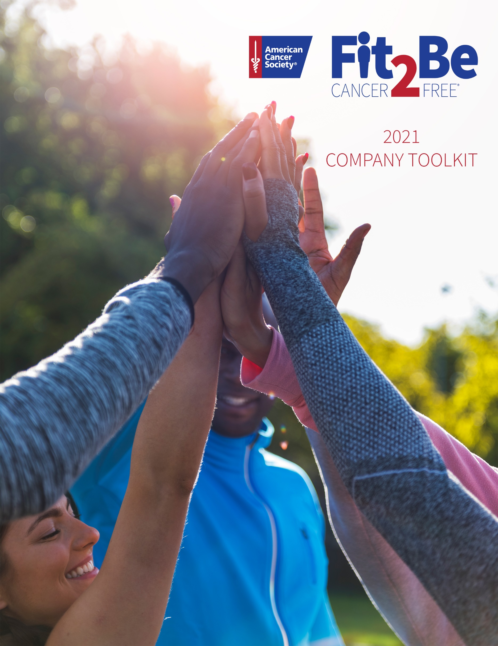

CONTENTS

Welcome 03

Getting Started 04

Communications 05
Social Media 10

How to Sign Up 16

Fundraising Tips 17

WELCOME

CONGRATULATIONS on taking a big step in making health and wellness a priority at your organization!

Fit2BeCancerFree is a virtual step-tracking fitness and fundraising event to promote cancer prevention in the workplace. We know nearly half of all cancer deaths are caused by risk factors such as smoking, excess weight, and physical inactivity, which is why living a healthy lifestyle is important.
Fit2BeCancerFree makes fitness fun for everyone. Like any good health and exercise regimen, you’ll need consistency, support from key people, and the right strategies to maintain motivation. That’s why we created this toolkit to help you implement a successful wellness & giving challenge.
GETTING STARTED
FIRST, get stakeholders on board!

Through experience from partnering with over 1,000 companies, we see the most successful wellness programs have top leadership promoting and actively participating in the program. When managers support the wellness program, employees naturally engage.

Once leadership is onboard, it’s essential that they lead the way in participation and interaction. Their involvement will inspire others to give and get moving.
HERE ARE SOME WAYS TO GET LEADERSHIP INVOLVED:

•Make sure the management team is the first to sign up for Fit2BeCancerFree.  •Share the usernames of each executive so users  can recognize them in the app and see them  participating with the rest of the organization.  •Leaders and managers should send  communications out encouraging everyone to  participate. Bonus points if they explain how  easy it was to sign-up and why they are  personally excited for this program.  •Have leadership reference challenge scores,  fundraising efforts and/or top performing  groups at company-wide events, not just when  your challenge starts. | •Create a challenge where the rest of the  company is competing to beat the CEO.  •Ensure management is engaging through more  than steps; have them regularly liking content,  leaving comments and sending messages in  chat feature.  •Have leadership hand deliver or announce  prizes to the winners. (if applicable)

COMMUNICATIONS

Communication is everything
Sending well timed communication with reminders and instructions is critical to the success of your program. We provide email communication templates that are easy to customize by inserting your organization details, such as company name or challenge start date. Don’t fret about the timing—our set of templates come with our recommended schedule.

EMAIL COMMUNICATION TIMELINE BEFORE/DURING:

EMAIL COMMUNICATION TIMELINE DURING/AFTER CHALLENGE:

COMMUNICATION TEMPLATES:
Message 2 Weeks Before:
Sign-up Message (April 15th or 16th) – Create a marketing email to send out to your entire organization explaining why your organization is doing this campaign, we recommend language from executive leadership and also if possible, if you can send out from your executives (CEO if possible) email address to invite employees to join. After your marketing portion of the email, copy and paste this “How-To” section here below;
Our challenge starts on April 29th
Lace up your tennis shoes and stretch your hammies for the Fit2Be Cancer Free challenge!
- Dates of challenge: April 29th- May 20th
- We are participating in a custom journey, virtual race with fun surprise milestones that you can unlock along the way. The goal is to move a
total distance of 70 miles over the duration of the challenge and for our company to raise [insert fundraising goal] toward the fight against cancer.
How to sign up
You can access the MoveSpring app by creating an account on app.movespring.com or by downloading the iOS or Android app.
- Click this join link: [Insert challenge link]
*You’ll be navigated to the MoveSpring website, or to download the mobile app if you click the link from your mobile phone. It is ideal to download the app on your phone so you can connect your tracking device at the same time.
- Enter the following org code if/when prompted: [Org code] (not case sensitive), then confirm [Org name] as the organization
- Follow the steps to create your MoveSpring account and connect a device.
Once your account is created you’ll automatically be added to the challenge.
Then visit our company fundraising page [insert link to company page] where you will have the opportunity to create your own fundraising webpage if you’d like to help us reach our company wide goal of [insert company fundraising goal].
That’s it, you’re all set and ready to get moving!
Second Invite / Communication for Sign-ups – (April 22nd or 23rd ) – Send an email (from executive, CEO email or corporate communications recommended) to remind employees of the initiative and that it starts in 1 week. After your marketing portion of the email, copy and Paste this “How-To” section here below;
- Dates of challenge: April 29th- May 20th
- We are participating in a custom journey, virtual race with fun surprise
milestones that you can unlock along the way. The goal is to move a total distance of 70 miles over the duration of the challenge and for our company to raise [insert fundraising goal]

How to sign up
You can access the MoveSpring app by creating an account on app.movespring.com or by downloading the iOS or Android app.
- Click this join link: [Insert challenge link]
*You’ll be navigated to the MoveSpring website, or to download the mobile app if you click the link from your mobile phone. It is ideal to download the app on your phone so you can connect your tracking device at the same time.
- Enter the following org code if/when prompted: [Org code] (not case sensitive), then confirm [Org name] as the organization
- Follow the steps to create your MoveSpring account and connect a device.
Once your account is created you’ll automatically be added to the challenge.
That’s it, you’re all set and ready to get moving!
Last Call for Sign-Ups – (Final Communication, April 27th) – Send final email (from executive email, CEO or corporate communications recommended) to remind employees of the initiative and that it starts in 2 days. After your marketing portion of the email, copy and paste this “How-To” section here below;
- Dates of challenge: April 29th- May 20th
- We are participating in a custom journey, virtual race with fun surprise milestones that you can unlock along the way. The goal is to move a total distance of 70 miles over the duration of the challenge and for our company to raise [insert fundraising goal]

How to sign up
You can access the MoveSpring app by creating an account on app.movespring.com or by downloading the iOS or Android app.
- Click this join link: [Insert challenge link]
*You’ll be navigated to the MoveSpring website, or to download the mobile app if you click the link from your mobile phone. It is ideal to download the app on your phone so you can connect your tracking device at the same time.
- Enter the following org code if/when prompted: [Org code] (not case sensitive), then confirm [Org name] as the organization
- Follow the steps to create your MoveSpring account and connect a device.
Once your account is created you’ll automatically be added to the challenge.
That’s it, you’re all set and ready to get moving!

During Challenge Messages
- First Day of Challenge Message
- Halfway Through Challenge Message
- 2 Days Remaining Challenge Message
Post-Challenge Messages
- Challenge Results Message - 3 Days After Challenge Ends

SOCIAL MEDIA

Social Media Tips & Tricks

We encourage all #Fit2BeCancerFree participants to share their involvement in the American Cancer Society’s national fitness challenge via social media, either through a personal account and/or a company account. Use #Fit2BeCancerFree and #AttackingCancer in all your posts to join the conversation. Keeping the momentum on social media can be easy. Here are some thoughts on key points for engaging your social media network:

- Before April 29: Leading up to the “CEO Challenge Day” on April 29, share that you’ve signed up to join the ACS in this unique, virtual step-tracking event.
- On April 29 – “CEO Challenge Day”: On challenge day, don’t forget to look out for and engage with posts from the American Cancer Society’s CEO on Twitter, @AmerCancerCEO.
- On April 30 – Celebrating the CEO Winner & Encouraging Employees: Engage with and share posts from the ACS’s CEO on Twitter, @AmerCancerCEO, and other participating CEOs
- Weekly Motivation: Post weekly, to let others know the importance of building more physical activity into their workday, while also sharing your support of the Society’s mission to save more lives from cancer.
- After May 20 – Celebrating the Employee Winner: Engage with and share posts from the ACS’s CEO on Twitter, @AmerCancerCEO, and other participants.

Check out the table below for best practices when sharing your participation across all social media channels.

Channel | Optimal Media Type | Optimal Video Length | Optimal Copy Length | Optimal Image Size | Best For
 | Video,  Photos | :15 to under 2:00 | Under 120 characters | 1:1 | Telling personal stories of impact. Share why you’re participating in the Fit2Be Cancer Free challenge with family and friends.
 | Video,  Photos,  Links | :06 to :30 | Under 140 characters | 1:1 | Retweeting news and engaging with your employees, participants and community members discussing the challenge.
 | Photos,  Short Videos | :06 to :15 | Under 150 characters | 1:1 | Photography from events, real-time moments. Share a picture of your activity.
Stories | Videos,  Boomerangs,  Photos | Under :15 | n/a | 9:16 | Highlighting real-time events with location tagging. Share a few snapshots of your company’s activations on challenge day.
 | Links to articles  Photos | n/a | Under 100  characters | 1:1 | Sharing news about your business, corporate partners, announcements, etc. Share why you’re supporting ACS with your connections.

Social Media Thought Starters
Always tag us and use our hashtags!
Tag us in any content you post:  - Twitter: @AmericanCancer  - LinkedIn: American Cancer Society  - Instagram/Instagram Stories: @AmericanCancerSociety  - Facebook: @AmericanCancerSociety | Use our hashtags across all channels:  - #Fit2BeCancerFree  - #AttackingCancer  - #CEOsAgainstCancer

Share some facts:
- 1 in 3 people in the US will be diagnosed with cancer in their lifetime.
- Every 19 seconds another American will hear the words, ‘You have cancer.”
- Research shows that poor diet and physical inactivity are 2 key factors that can increase your cancer risk.

Content Thought Starters:
- Post pictures of how you’re being more physically active during the workday to encourage your colleagues to do the same.

- Challenge your colleagues and peers to join you in inspiring more movement! Encourage them to post on their personal social channels, highlighting how they’re participating in the challenge or supporting you.

- Encourage others to check out the live leaderboard. Share where you stand in the Top 20 ranking throughout the day.

Sample Social Media Content

Sample Content CEO Challenge:

- Did you know that 1 in 3 people will be diagnosed with cancer in their lifetime? That’s why I’ve signed up for @AmericanCancer’s #Fit2BeCancerFree CEO fitness challenge. Donate to support my efforts: (insert company link) #AttackingCancer

- I’m stepping up to fight against cancer with @AmericanCancer during the #Fit2BeCancerFree challenge on July 16! Donate now to support my efforts: (insert company link)

- I’ve signed up for @AmericanCancer’s #Fit2BeCancerFree CEO fitness challenge in support of #CEOsAgainstCancer! Learn more: cancer.org/ceochallenge #AttackingCancer

- Today is the #Fit2BeCancerFree challenge! Track my progress and learn how you can support @AmericanCancer at movespring.com/acs-fit2be #CEOsAgainstCancer #AttackingCancer

- It’s the #Fit2BeCancerFree CEO Challenge day! Donate today to support my fundraising efforts for @AmericanCancer: (insert company link) #CEOsAgainstCancer #AttackingCancer

For Participants’ Companies:
- Our own [insert name or Twitter handle] is participating in the @AmericanCancer #Fit2BeCancerFree CEO challenge! Make your donation in support of [insert name] to help us fight cancer: (insert company link) #CEOsAgainstCancer #AttackingCancer

- See where [insert name or Twitter handle] ranks vs. other CEOs in the AmericanCancer #Fit2BeCancerFree CEO fitness challenge at https://movespring.com/acs-fit2be #CEOsAgainstCancer #AttackingCancer
- Our own [insert name or Twitter handle] is taking part in @AmericanCancer’s #Fit2BeCancerFree CEO challenge! See the leaderboard at https://movespring.com/acs-fit2be #CEOsAgainstCancer #AttackingCancer

Social Content for Employee Participants:

- Did you know that 1 in 3 people will be diagnosed with cancer in their lifetime? That’s why I’ve signed up for @AmericanCancer’s #Fit2BeCancerFree national challenge. Learn more: https://movespring.com/acs-fit2be #AttackingCancer

- I’m stepping up to fight against cancer with @AmericanCancer during the #Fit2BeCancerFree national challenge starting July 16! Donate today to support my efforts: (insert company link)

- I’ve signed up for @AmericanCancer’s #Fit2BeCancerFree national challenge in support of #AgainstCancer! Make a donation to support my efforts: (insert company link)

- Today is the #Fit2BeCancerFree national challenge! Track my progress and learn how you can support @AmericanCancer at (insert company link)

- I’m participating in the @AmericanCancer #Fit2BeCancerFree national challenge! Show your support by donating to help fight cancer: (insert company link) #AttackingCancer

- Today is the last day of the #Fit2BeCancerFree challenge! Support @AmericanCancer by donating today: (insert company link)

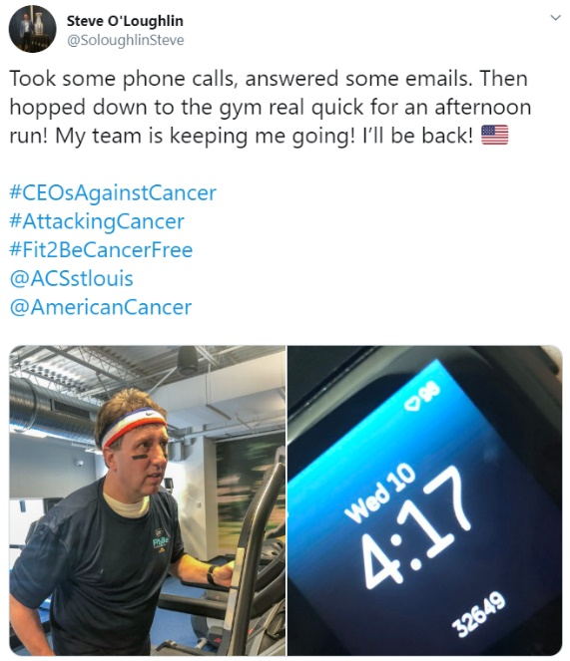
Sample Posts:
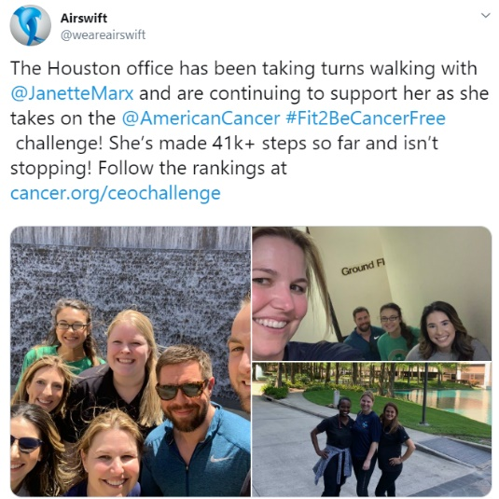
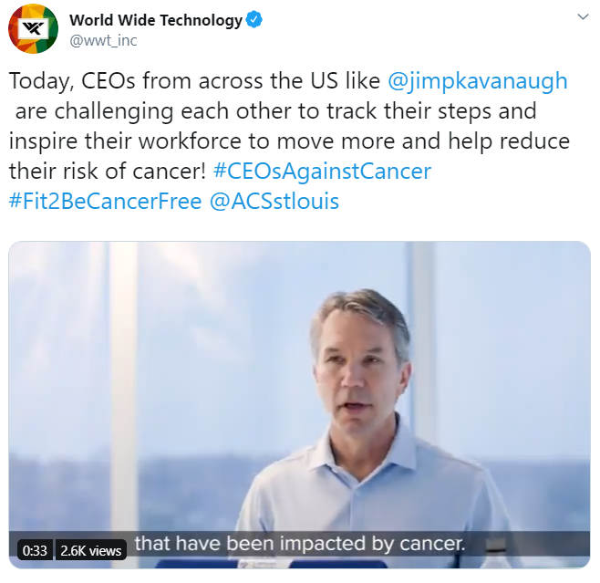

Sample Posts:

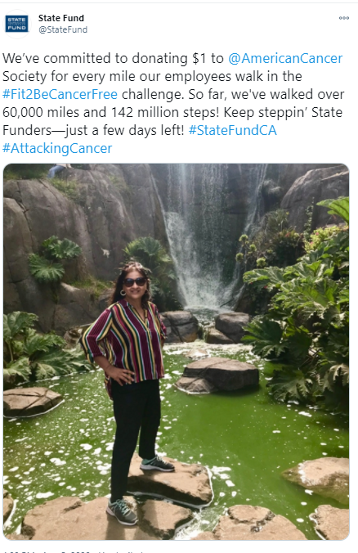
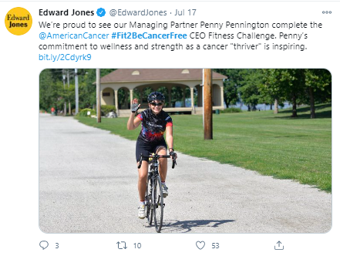

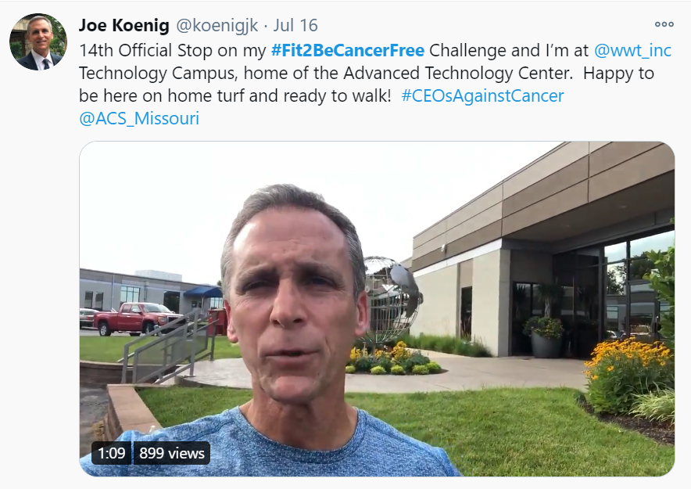

HOW TO SIGN UP

STEP #1: STEP #2:
Download the Movespring App Enter your Fit2Be Cancer Free code
in iTunes or GooglePlay to join the challenge
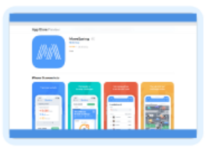 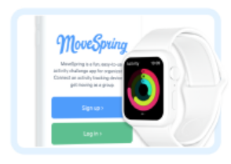

STEP #3: STEP #4: Video Link
Create your profile as you Connect your device by selecting your
want your name to be displayed wearable or smart phone device
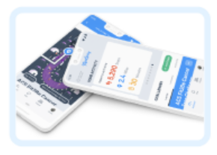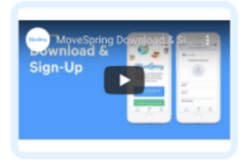

FUNDRAISING TIPS

Personalize your individual fundraising to include activities that will interest your networks. While your fundraising possibilities are endless, here are some ideas to get you started.

NEW TO FUNDRAISING? FOLLOW THESE EASY STEPS TO GET STARTED!

- Personalize your fundraising page on your company’s custom fundraising tracking website with your personal story and photo, then share the link to your page with friends and family. *Your company admin should provide you with the company fundraising page link.
- Start your campaign by making a personal donation. Your friends, family, and business contacts will realize how important this cause is to you.

- Coordinate a fundraising effort tied to an activity you commit to doing if you hit a fundraising milestone. For example, maybe you will be up for wearing a tutu for a day or dye your hair pink when you hit your fundraising goal!
FRIENDS, FAMILY, PEERS, AND BUSINESS CONTACTS

• Send emails or letters to friends and family (don’t forget those out of town), asking them to make a donation to your campaign.
• Text your close friends with a link to make a donation. Ask them to donate $10
and to ask 10 of their friends to donate $10!
• Do an activity for a donation. “For a $25 donation, I will do 25 push-ups and post it
on my social media!”

SOCIAL MEDIA

• As you share your pictures and information about the Fit2Be Cancer Free Challenge, ask followers to make a donation to help you become the top fundraiser, or team, and support your mission to help save lives from breast cancer.
• Offer friends the chance to honor a loved one. For a certain donation (your choice), post a picture of someone whom your friend wants to honor or
remember.
• Provide updates on your fundraising progress through your social media networks, and always provide a link to your personal fundraising website.

COORDINATE AN OFF-SITE FUNDRAISER

• Ask a local business to donate an item (such as a cooler, golf or fishing outing, restaurant gift certificate, weekend at a condo, gym membership, etc.), and ask friends and family to sell chances to win the prize(s). Draw the winner on the last day of the challenge.
• Ask a local business (or your business) to host an employee dress-down day – $10 for the opportunity to wear jeans on Friday.
• Ask a local business to host a fundraiser, or have a local restaurant donate a portion of their proceeds to your campaign.

